

**Kauno technologijos universitetas**

fACULTY OF INFORMATICS

**T120B166 Development of Computer Games and Interactive Applications**

*Party Table Game - Saboteur*

IFF-6/11 Nerijus Dulkė

Date: 2019.03.05

KAUNAS

2019

**Contents**

Table of images 3

Table of Tables/functions 4

Game description 5

Laboratory work #2 6

List of tasks 6

Solution 6

Task #1 and #2. Create a terrain, color it, seed trees of your own construction 6

Task #3. Import a unique model and assign it to a third person character controller 10

Task #4. Add and animate 5 objects to your game map 11

Task #5. Create 5 unique particle effects 11

Task #6. Add a custom skybox 16

Task #7. Create 5 different physics materials 17

Task #8. Assign colliders for all 3D objects imported in the first laboratory work 18

Task #9. Add and animate 5 objects using physics, force and triggers to your game map 19

Task #10. Set static flag to all immobile objects and measure batching performance 20

Task #11. Try deferred vs forward rendering and measure performance for both 21

Task #12. Bake a lightmap for your scene and measure performance 21

Task #13. Optimize all textures and measure graphical memory load 22

Task #14. Try hard vs soft shadows and measure performance 22

Defense task 23

Literature list 24

# Table of images

Figure 1 Colored terrain with seeded trees 6

Figure 2 Different terrain layers 7

Figure 3 Tree #1 7

Figure 4 Tree #2 8

Figure 5 Tree #3 8

Figure 6 Tree #4 9

Figure 7 Tree #5 9

Figure 8 Model with third person character controller 10

Figure 9 Animated pickaxe 11

Figure 10 Fire effect particle system 12

Figure 11 Explosion particle system 13

Figure 12 Gold effect particle system 14

Figure 13 Smoke particle system 15

Figure 14 Water splash particle system 16

Figure 15 Physics materials 18

Figure 16 Colliders 19

Figure 17 Chest animation controller 20

Figure 18 Forward rendering performance 21

Figure 19 Deferred rendering performance 21

Figure 20 Default performance 21

Figure 21 Performance with baked lightmap 21

Figure 22 Default memory stats 22

Figure 23 Memory stats with optimized textures 22

Figure 24 Performance with hard shadows 22

Figure 25 Ragdoll 23

# Table of Tables/functions

Table 2 Trigger script 20

# Game description

1. **3D or 2D?** 3D
2. **What type is your game?** Board sgame
3. **What genre is your game?** Party game
4. **Platforms:** PC
5. **Scenario description:** In this game action is set in a mine. Players take on the role of dwarves, some are miners, some are saboteurs, but no one knows who is on their side. For miners goal is to get to the gold until the cards run out. For saboteurs the goal is to stop miners from reaching gold. After three rounds the player with the most gold wins.

# Laboratory work #2

## List of tasks

1. Create a terrain and color it using 5 or more materials.
2. Create 5 trees of your own construction and seed them using terrain tools.
3. Import a unique model and assign it to a third person character controller.
4. Add and animate 5 objects to your game map.
5. Create 5 unique particle effects.
6. Add a custom skybox.
7. Create 5 different physics materials and apply then in your project.
8. Assign an optimum collider based on the shape of the object for all 3D objects imported in the first laboratory work.
9. Add and animate 5 objects using physics, force and triggers to your game map.
10. Set static flag to all immobile objects and measure batching performance.
11. Try deferred vs forward rendering and measure performance for both.
12. Bake a lightmap for your scene and measure performance.
13. Optimize all textures depending on their parameters and measure graphical memory load.
14. Try hard vs soft shadows and measure performance.

## Solution

### Task #1 and #2. Create a terrain, color it, seed trees of your own construction

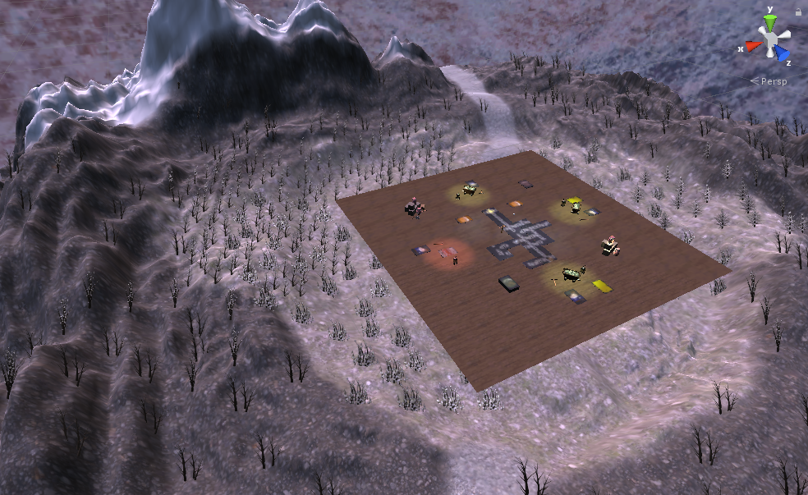

Figure 1 Colored terrain with seeded trees

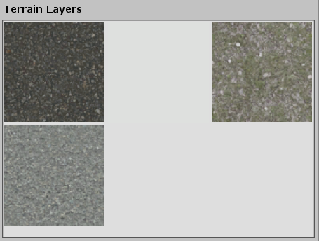

Figure 2 Different terrain layers

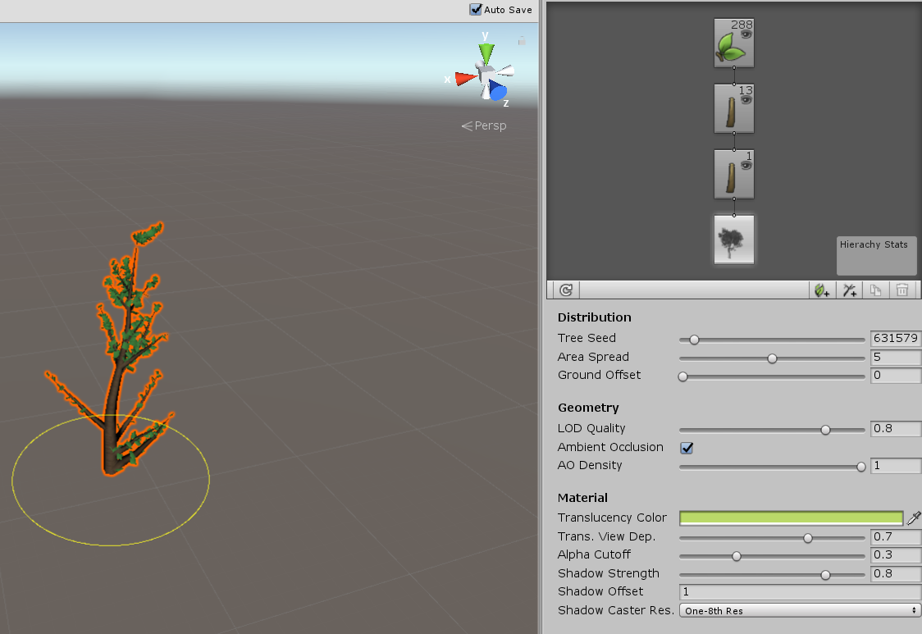

Figure 3 Tree #1

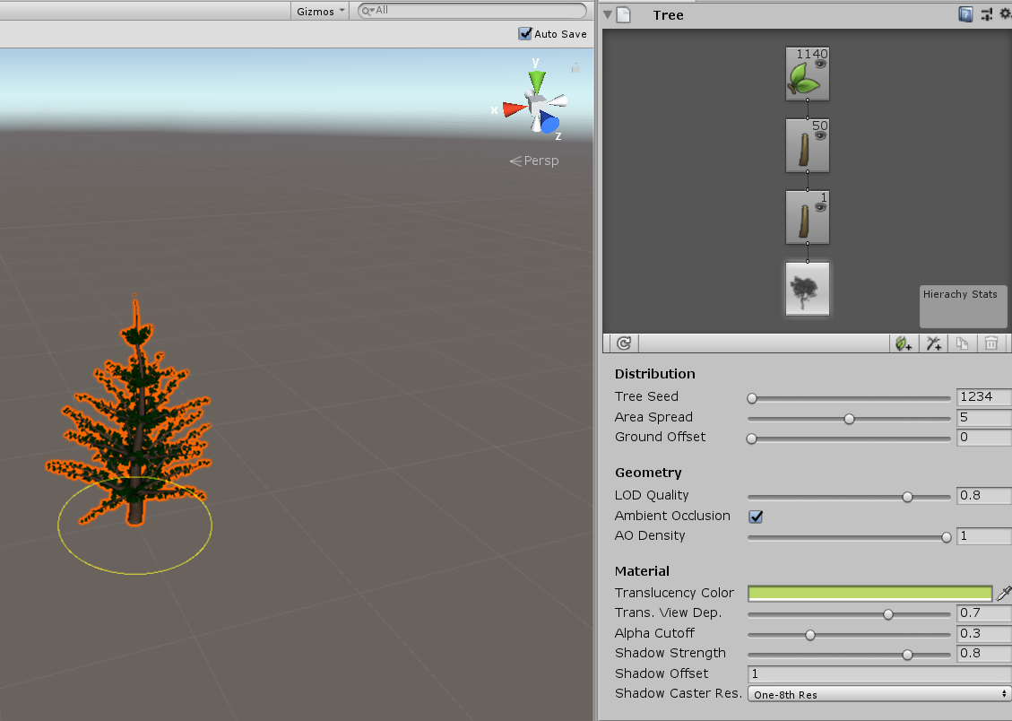

Figure 4 Tree #2

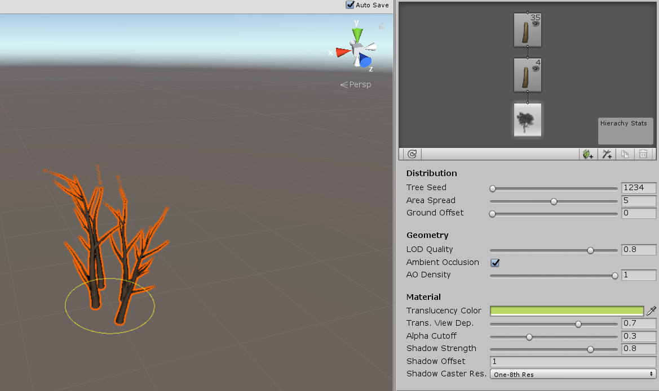

Figure 5 Tree #3

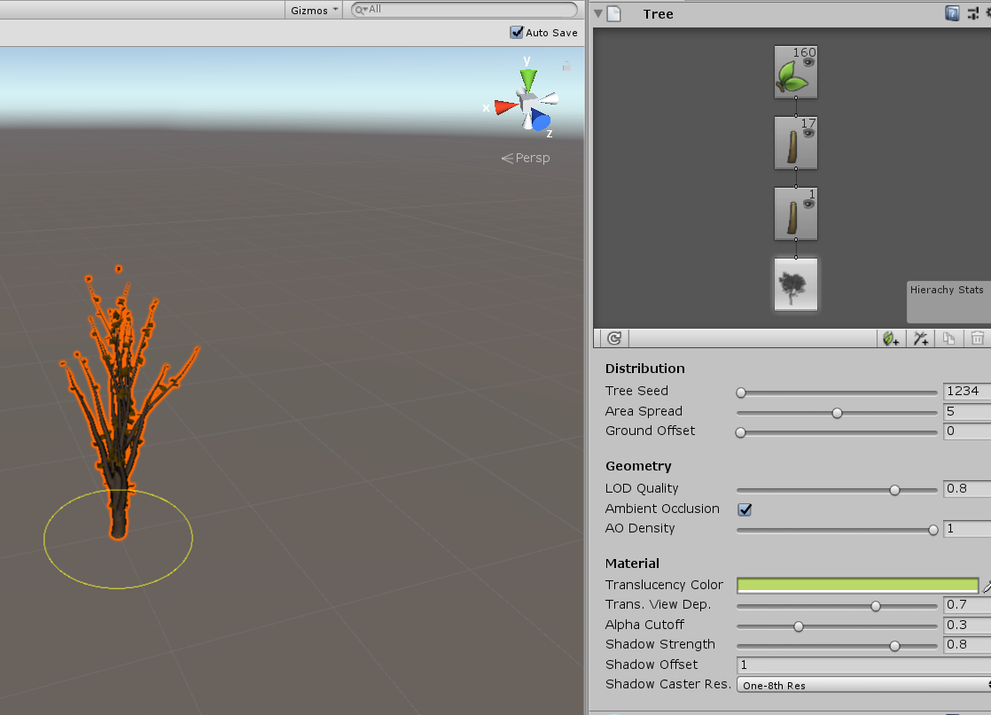

Figure 6 Tree #4

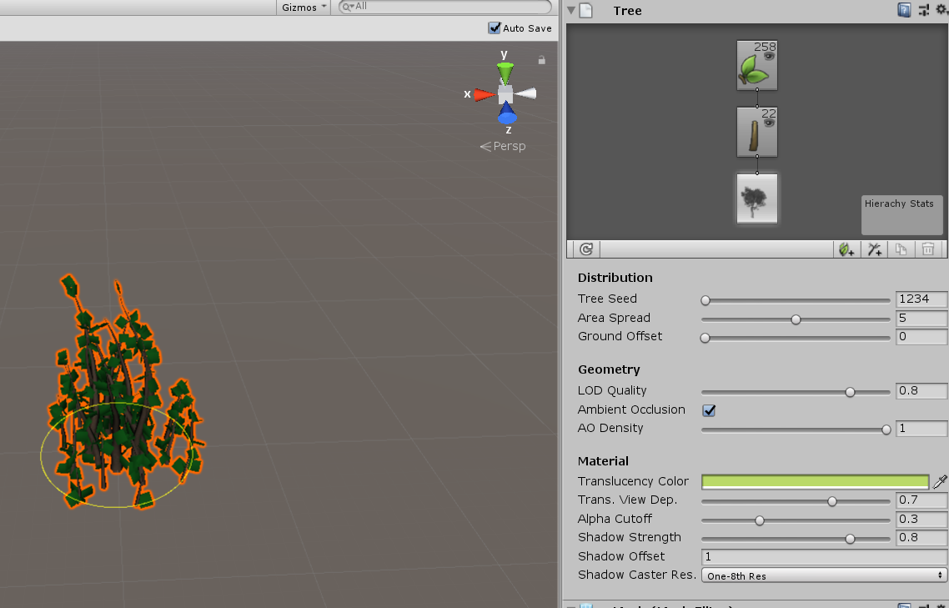

Figure 7 Tree #5

### Task #3. Import a unique model and assign it to a third person character controller

Model taken from [here](https://sketchfab.com/3d-models/elysiumvr-male-character-rigged-template-4d0f03c673474921804254658666710d).

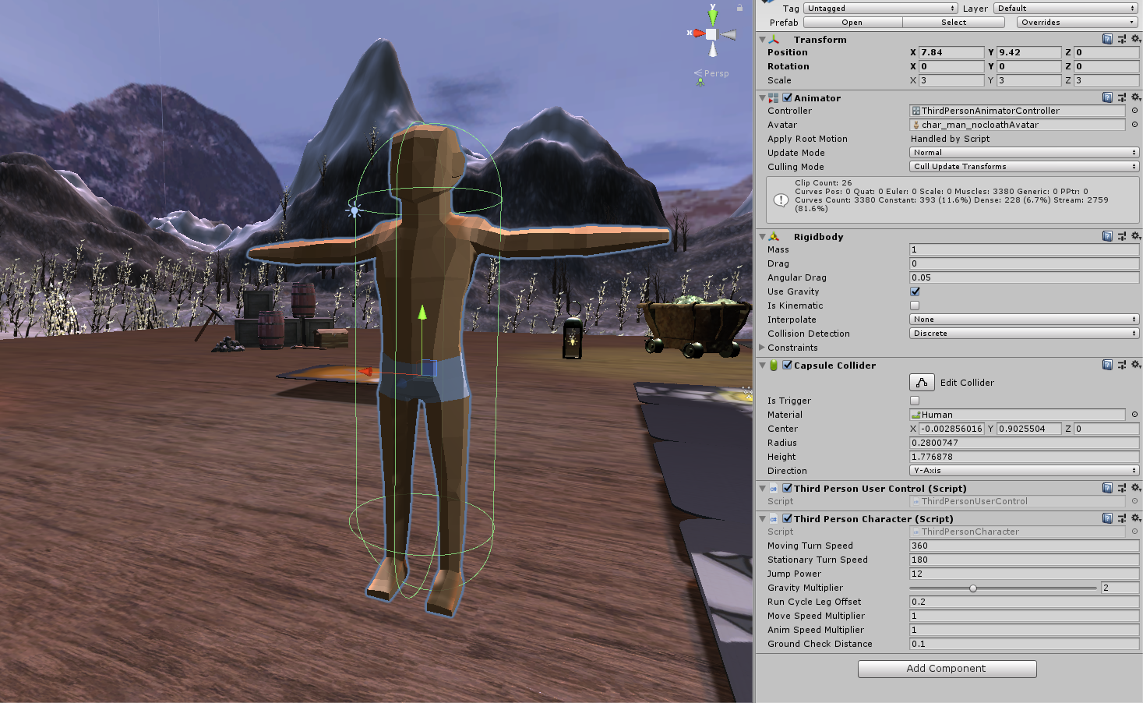

Figure 8 Model with third person character controller

### Task #4. Add and animate 5 objects to your game map

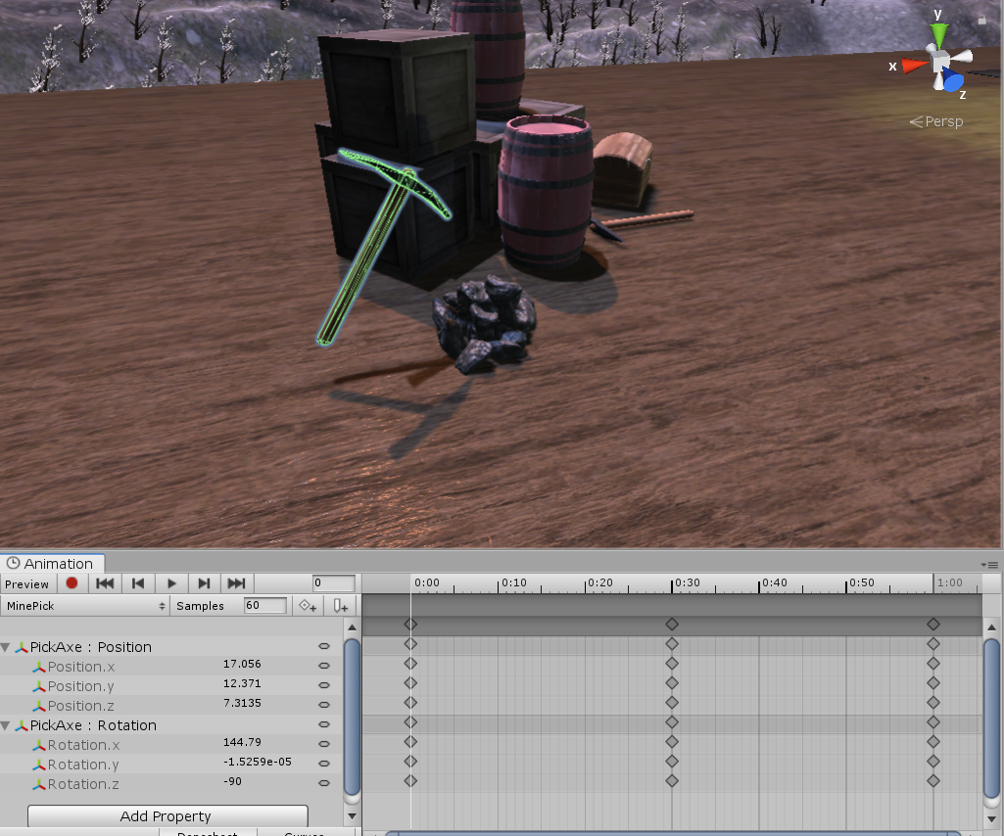

Figure 9 Animated pickaxe

### Task #5. Create 5 unique particle effects

5 different particle systems added to game:

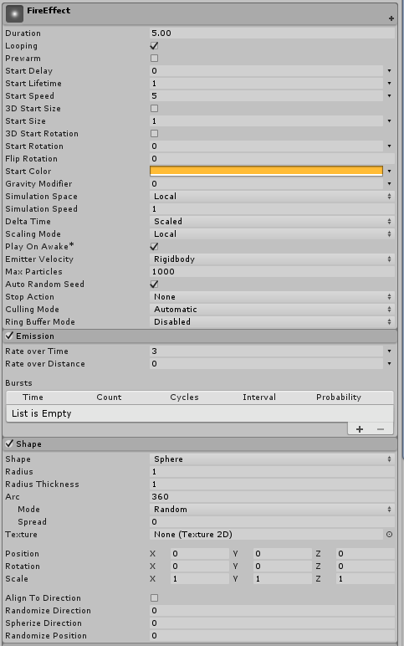 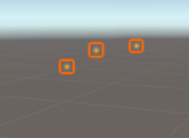

Figure 10 Fire effect particle system

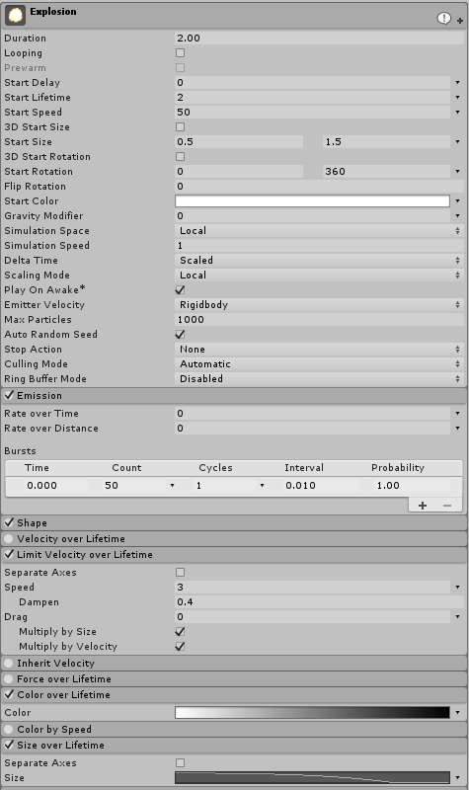 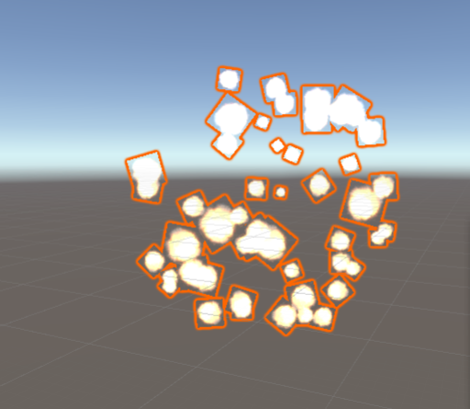

Figure 11 Explosion particle system

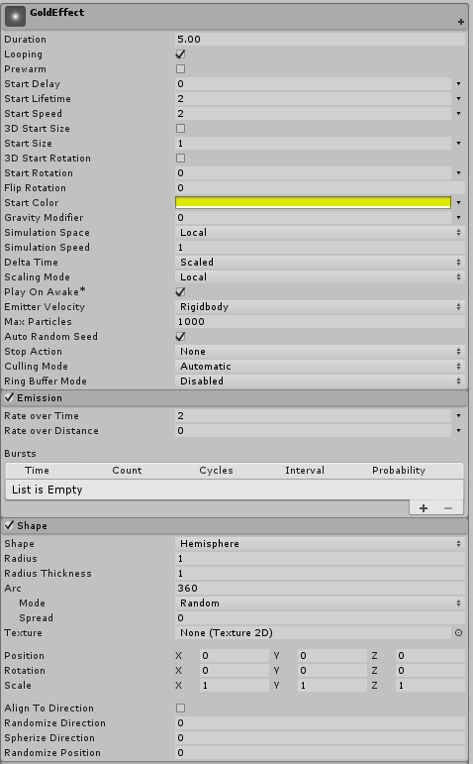 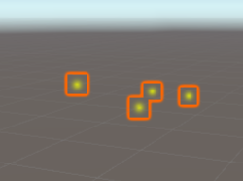

Figure 12 Gold effect particle system

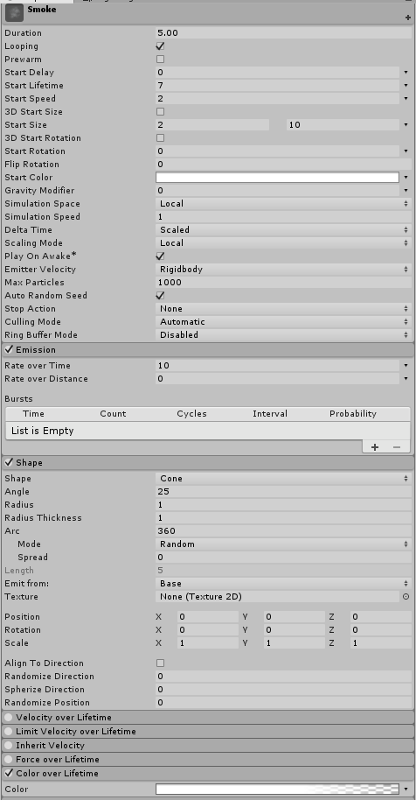 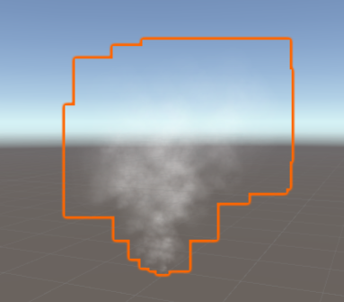

Figure 13 Smoke particle system

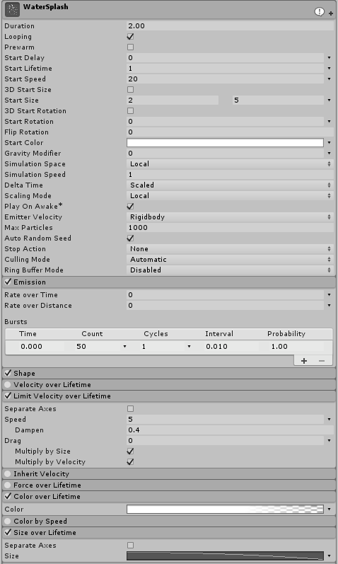 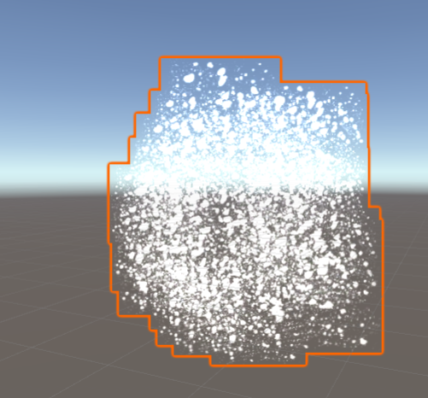

Figure 14 Water splash particle system

### Task #6. Add a custom skybox

Skybox textures taken from [here](http://www.custommapmakers.org/skyboxes.php) and used in a skybox type material.

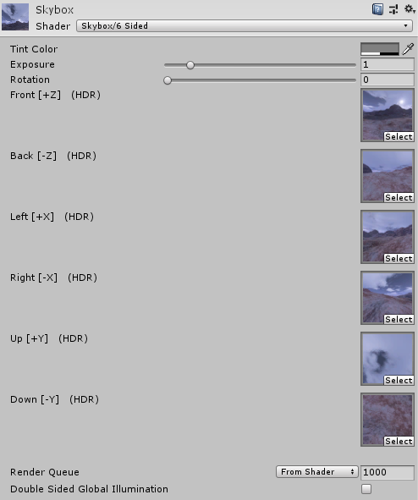

### Task #7. Create 5 different physics materials

Added 4 different physics materials:

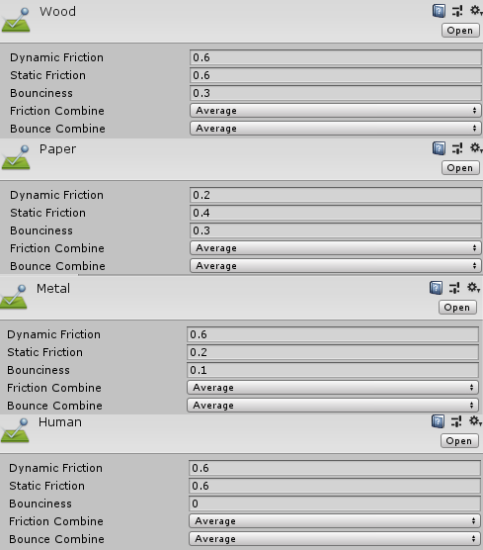

Figure 15 Physics materials

### Task #8. Assign colliders for all 3D objects imported in the first laboratory work

Assigned different types of colliders for all props.

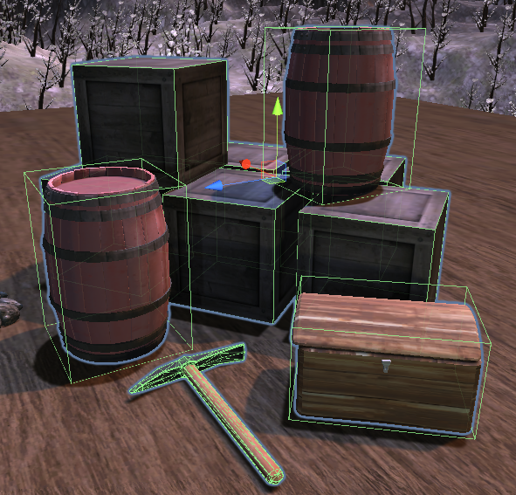

Figure 16 Colliders

### Task #9. Add and animate 5 objects using physics, force and triggers to your game map

Chest is animated using triggers. On trigger enter chest opens and on trigger exit chest close. Mining pickaxe plays and loops animation when game is started.

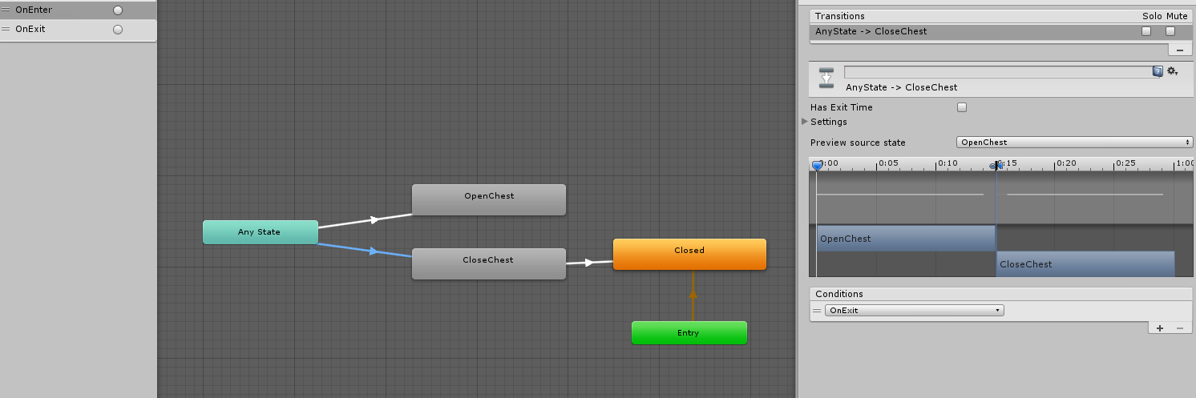

Figure 17 Chest animation controller

Table 1 Trigger script

|  |
| --- |
| public class Trigger : MonoBehaviour  {  Animator animator;  void Start()  {  animator = GetComponent<Animator>();  }  void OnTriggerEnter(Collider collider)  {  animator.SetTrigger("OnEnter");  }  void OnTriggerExit(Collider collider)  {  animator.SetTrigger("OnExit");  }  } |

### Task #10. Set static flag to all immobile objects and measure batching performance

Batches with static flags: 1315

Batches without static flags: 1345

### Task #11. Try deferred vs forward rendering and measure performance for both

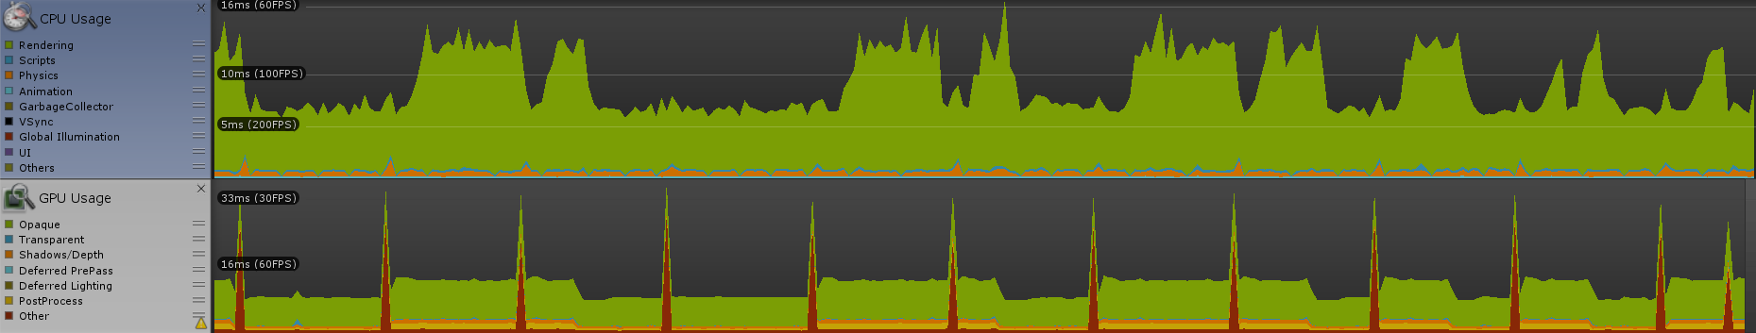

Figure 18 Forward rendering performance

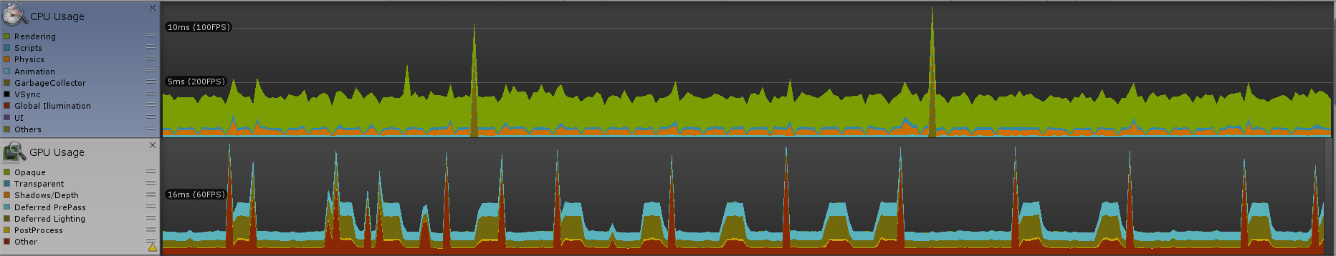

Figure 19 Deferred rendering performance

### Task #12. Bake a lightmap for your scene and measure performance

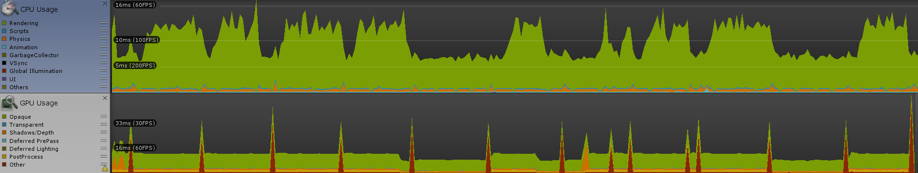

Figure 20 Default performance

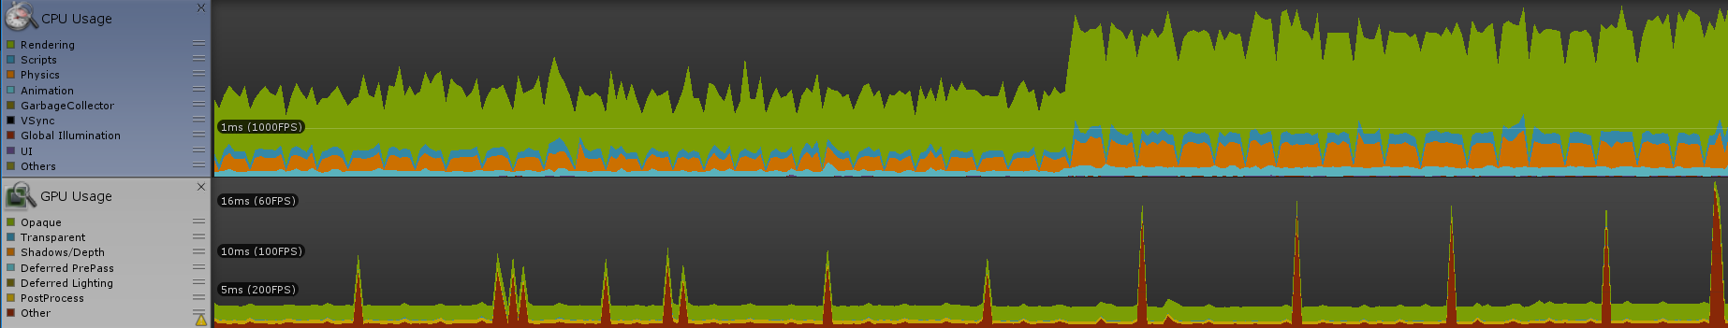

Figure 21 Performance with baked lightmap

As seen in the first picture (Figure 20), majority of CPU time is used on rendering. With baked lightmap rendering time decreased.

### Task #13. Optimize all textures and measure graphical memory load

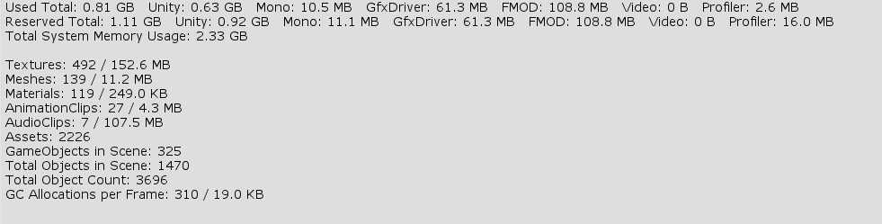

Figure 22 Default memory stats

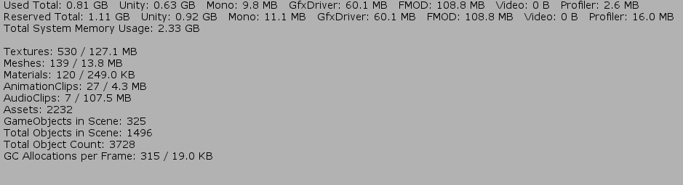

Figure 23 Memory stats with optimized textures

Comparing these two images we can see that memory load for textures decreased by around 30MB.

### Task #14. Try hard vs soft shadows and measure performance

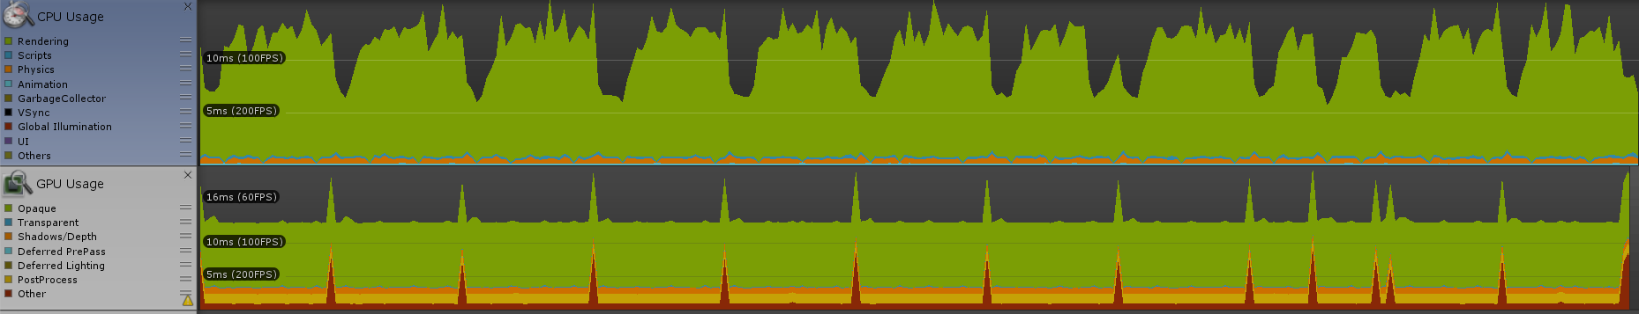

Figure 24 Performance with hard shadows

Default performance (Figure 20) was measured with soft shadows so we can use that for comparison. From these two images we can see that rendering hard shadows uses a lot more CPU time.

### Defense task

Adding a ragdoll:

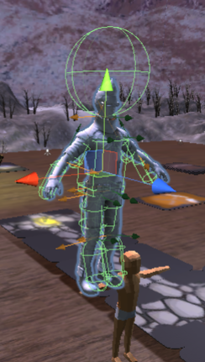

Figure 25 Ragdoll

# Literature list

Resources used from:

* <https://www.textures.com/download/pbr0139/133174>
* <https://www.textures.com/download/3dscans0079/128150>
* <https://www.freelancer.com/contest/Concept-Art-SKETCH-Gnome-390351-byentry-8768095>
* <https://www.freepik.com/free-vector/cartoon-stone-texture_976364.htm>
* <https://www.vectorstock.com/royalty-free-vector/mine-cart-with-coal-vector-1747485>
* <https://all-free-download.com/free-vector/download/treasure-map-clip-art_23028.html>
* <https://www.kisspng.com/png-cartoon-ladder-illustration-cartoon-wooden-ladder-497343/>
* <https://www.turbosquid.com/3d-models/pickaxe-obj-free/912027>
* <https://sketchfab.com/3d-models/mine-cart-2beeab5f44704421bc10cd310db96860>
* <https://www.textures.com/download/3dscans0110/130564>
* <https://www.textures.com/download/pbr0031/133067>
* <https://sketchfab.com/3d-models/lantern-final-aead6bb3bab344eaab541c5ac52c657c>
* <https://sketchfab.com/3d-models/40-rocks-a6c5ab5b438f473cb1cafdf4099e1657>
* <https://free3d.com/3d-model/crate-86737.html>
* <https://free3d.com/3d-model/barrel-7685.html>
* <https://free3d.com/3d-model/wooden-chest-44006.html>
* sounds from <https://www.productioncrate.com> and <https://www.zapsplat.com>
* <https://www.textures.com/download/pbr0172/133207>
* <https://www.textures.com/download/asphaltcloseups0064/12319>
* <http://www.custommapmakers.org/skyboxes.php>
* <https://sketchfab.com/3d-models/elysiumvr-male-character-rigged-template-4d0f03c673474921804254658666710d>